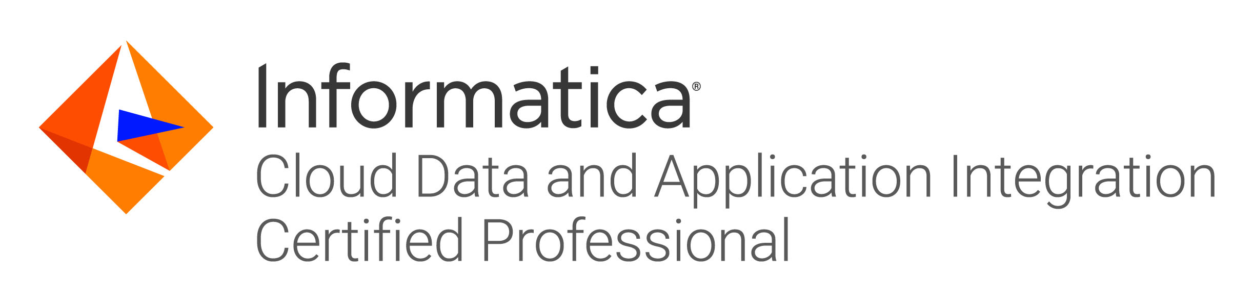

Garima Khanna
garimak.2020@gmail.com
Mob: +91 9582130557

Experience Summary

- 6.3years of professional experience in IT Industry and Certified developer from Informatica.Having competency in Development, Testing, Deployment and Support phase of SDLC cycle for Data warehousing applications. Currently working in Agile model.
- Extensively worked on Data Extraction, Transformation and Loading data from various sources like SQL Server, Flat files, SAP R/3, DB2, Salesforce, Snowflake, ServiceNow, Azure DevOps, Blob Storage, MS SharePoint flows, Azure Devops Standard API integrations.
- Worked on Python scripts development for automating complete IICS ETL jobs which include validation on data merge, duplication records & record count validation STG VS Reporting Tables.
- Worked extensively in development of new application where SAP system is the source system, and we must load data on incremental basis into SQL server db.
- Strong Database Experience with strong knowledge of writing complex SQL queries.
- Experience in UNIX shell scripting for automating manual processes.
- Experience in working with across the globe teams and Informatica Product team as well.
- Independently performed complex troubleshooting, root-cause analysis, and solution development.
- Worked on Informatica Cloud enhancements and daily routine checks where source as Salesforce loading data to Magento MySQL on incremental basis.
- Have excellent analytical, problem solving, communication and interpersonal skills, with ability to interact with individuals at all levels and work as a part of a team as well as independently.
Technical Skills

ETL Tools | InformaticaPowerCenter, Informatica Cloud (IICS), MS SharePoint Flow
Database | SQL Server 2012, IBM DB2, Snowflake
Scheduling Tools | Crontab
ScriptingLanguage | Unix, PowerShell, Python
Domain | Retail, Manufacturing, US Mortgage
Other Tools | WinSCP, Putty, BMC Remedy, Snow, Azure DevOps, ServiceNow
Work Experience

Organization Name | Designation | Year
Assimilate Solutions | Senior Software Engineer | May 2019 - Present
Project 1-

Client Name | Home Point Financials, US | Team Size | 10
Start Date | May 2019 | End Date | Present
Description | Home point Financials is a US mortgage company headquartered in US Glen Mills that deals with customer for providing home loans in US. Assimilate is involved in development of its applications and data warehouse which provide services to its end users.
Role & Contribution | - Involved in understanding of business user’s requirements.  - Developing ETL code on IICS and snowflake as DB as per user requirements.  - Involvement in creation of business view as per requirement.  - Scheduled runs of existing applications and deliver the files to user location via batch & python to automate complete process.  - Created SharePoint flow to get the files from SharePoint and load it to windows server.
Tools | IICS, SQL Server, Snowflake, MS SharePoint Flow, Azure DevOps, Anaconda3.
Key Achievements | Owned the projects like Insight QC, eCDE project development and SharePoint flows.  Received Yearly PerformanceRecognition from MD of company.

Organization Name | Designation | Year
HCL Technologies Ltd. | Software Engineer | March 2015 – May 2019

Project 2-

Client Name | Axalta Coating Systems, US | Team Size | 5
Start Date | Jan 2015 | End Date | Present
Description | Axalta Coating Systems is a coatings company headquartered in US Glen Mills that manufactures coatings for vehicles, industrial and refinish applications. Previously, it was known as DuPont. Axalta Coating Systems is involved in maintenance and support of its applications and is providing services to its end users.
Role & Contribution | - Involved in understanding ofbusiness user’s requirements.  - Analysis of existing ETL before applying code change as and when requested by client.  - Developing, enhancing, and testing the ETL code as per user requirements.  - Supporting the scheduled runs of existing applications and resolving the issues encountered.  - Communicating with client as well as various teams involved in processes of high importance.  - Worked on automation of existing processes.
Tools | Informatica 9.5.1, ICS, SQL Server, SAP ABAP,Salesforce, DB2, Unix
Key Achievements | Given a value add to the client by developing a UNIX script for archive the file for vacating the unnecessary space from server.  In 2018 September, HCL has given Performance Excellence Award.

Project -3

Client Name | Husqvarna Group, Sweden | Team Size | 10
Start Date | March 2015 | End Date | Jan 2016
Description | Husqvarna Group is a global leading producer of outdoor power products for forest, park, and garden care. Products include chainsaws, trimmers, and robotic lawn mowers, ride-on lawn mowers, garden tractors, chainsaws, and trimmers.
Role & Contribution | - Monitoring daily ETL jobs informing the teams of any failure and maintaining load tracker.  - ETL and data analysis for bug fixing.  - Supporting the scheduled runs of existing applications and resolving the issues encountered.  - Communicating with client as well as various teams involved in the processes of daily data processing.  - Monitoring messages on AS400 system and informing team during critical messages received.
Tools | Informatica Cloud Services, AS400, Unix
Key Achievements | Involved in automation of health check of daily data of high importance.
Educational Qualification

Degree | Institution | Year of Passing | Percentage
GNIIT | NIIT | 2014 | 78%
B. Com | University of Delhi | 2014 | 72%
12th | CBSE | 2011 | 74%
10th | CBSE | 2009 | 77%

